VEHICLE CONTROL SYSTEM IMPLEMENTATION USING CAN PROTOCOL
AIM:
The main aim of this project is to display the engine temperature along with alert message, reverse alert and control the indicators using CAN protocol.

INSIGHT:
- Knowledge of Embedded-C programming
- Thorough with the LPC2129 Architecture, General purpose I/O Interface, ADC & CAN interface
- Understanding of CAN protocol

BLOCK DIAGRAM:
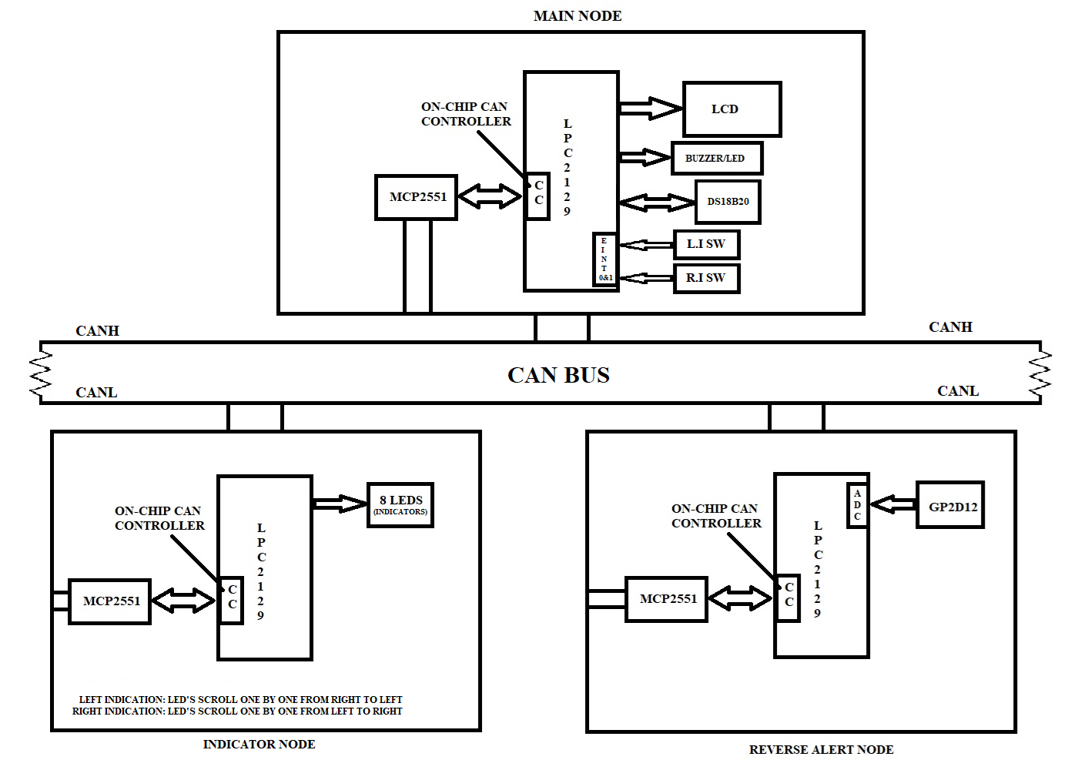

HARDWRAE REQUIREMENTS:

- LPC 2129
- CAN Transceiver (MCP2551)
- LEDS
- LCD
- GP2D12
- Switches
- DS18B20 Temperature Sensor
- USB to UART Converter

SOFTWARE REQUIREMENTS:

- EMBEDDED C – PROGRAMMING
- KEIL-C COMPILER
- FLASH MAGIC

SEQUENCE TO BE FOLLOWED FOR IMPLEMENTATION:
- Create New Folder in your server/laptop/PC and save that folder with your project name
- Individually can check each and every module.
- First check lcd to display character constant, string constant and integer constant.
- Next check the on-chip ADC by connecting variable voltage (from potentiometer) and display input value on LCD.
- Then develop logic for reading the temperature sensor (Engine temperature) information and display it (engine temperature) on LCD. (refer LMS for DS18B20 temperature working code)
- Then develop logic for reading the GP2D12 sensor (distance between object and vehicle/sensor) information and display it (Distance) on LCD.
- Then check the external interrupt (EINT0 & EINT1) working condition with the help of basic program.
- Then download the CAN basic code from LMS and test it on hardware.
- Once all the above modules are checked then start preparing the main code for each node.
- MAIN NODE: In continuous loop, Read the temperature information and display it on LCD. And set the limit for engine temperature in the application program. If current temperature is beyond the limit value, then give the indication by using one LED/LED’S. And based on the interrupt generated, need to send the indicator signal to the indicator node. And one more task of this main node is receiving the reverse alert node information and give the indication (LED/BUZZER ON/OFF) based on the value received by reverse alert node.
- INDICATOR NODE: Continuously waiting for the data from the main NODE using CAN. If any data is received from main NODE, based on that it is controlling the indicator signals connected to microcontroller. Refer the block diagram for how to give the indicator signals with the help of LED’S.
- REVERSE ALERT NODE: Continuously reading the GP2D12 sensor information with the help of on chip ADC and set one limit value to the sensor reading. If the sensor value is below the limit value sends logic 1 to the main node using CAN protocol. Or if the sensor value is greater than the limit value then sends the logic 0 to the main node using CAN protocol.
- If you’re getting this output then your project is completed.

*************************** ALL THE BEST ***************************

